Regional MAC Meetings:

Regional MAC Meetings are conducted quarterly through Zoom, taking place on the first Tuesday of every quarter, namely, in June, September, and December.

The Spring Meeting, scheduled for March, differs from the regular format. It offers the option for in-person attendance (which we strongly encourage) or participation via Zoom. This meeting is held on the Friday morning of our Seven Mountains EMS Conference.

Here is the schedule for the upcoming meetings for the 2023-2024 year:

- December 5, 2023, at 10:00 AM via Zoom
- March 8, 2024, at 10:00 AM, allowing for in-person participation during the Conference or via Zoom
- June 4, 2024, at 10:00 AM via Zoom
- September 3, 2024, at 10:00 AM via Zoom
- December 3, 2024, at 10:00 AM via Zoom

Meeting reminders will be sent out at three different intervals: one month in advance, two weeks in advance, and on the Friday just before the meeting.

You will find a link to RSVP for the meeting included with the two-week reminder and the Friday-before-the-meeting reminder. While we encourage RSVPs for better planning, they are not mandatory.

Additionally, you can expect to receive the meeting minutes from the previous gathering and any necessary documents as attachments with the Friday-before-the-meeting reminder.

Please note that Zoom Meetings will consistently use the same Meeting ID: 829 1132 7475.

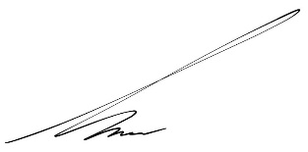
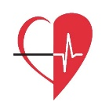  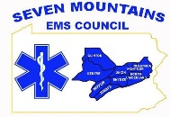 | Gage E. Lyons-McCracken  Pennsylvania CARES Coordinator  EMS Program Specialist  Seven Mountains EMS Council  Phone (814) 355-1474 Fax (814) 355-5149  Web www.smemsc.org Email glyons@smemsc.org  523 Dell Street, Bellefonte, PA 16823  Hours Monday – Friday 8:30am – 4:30pm

